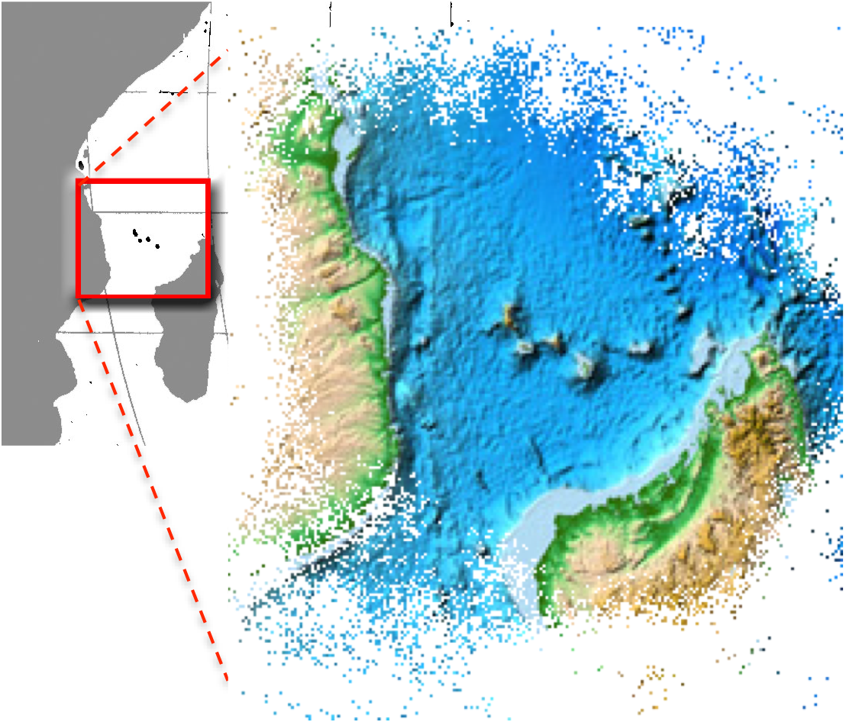
Developing a Theory of Change is an important process in developing a solution to complex problems, particularly when many different people, with different backgrounds and expectations, are involved.

This document presents a simplified process for developing a Theory of Change, targeting disparate and separated people and institutions interested in being a part of a ‘Northern Mozambique Channel’ programme or initiative. The goal is to go through the pages and write down your own versions of the text presented:

- the overall vision,
- your vision of success,
- how you think that success will be achieved in each of the main pillars of the programme, and thereby to the programme as a whole,
The WIOSAP vision:
“People of the region prospering from a healthy Western Indian Ocean”
- key intermediate (10 year) outcomes that we should be targeting through the projects, activities and short term outcomes we might implement in the next 3-5 years.
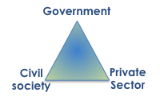
Where we have got to at present is:
- endorsement of basing the overall vision on the WIOSAP vision;
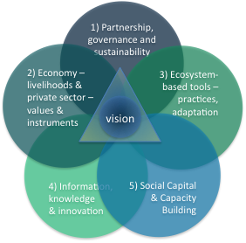
- that a partnership between government, civil society and the private sector is necessary to address the breadth of issues;
- that the Five Capitals approach gives a comprehensive foundation for building this complex and multi-faceted programme.

From this point, each individual/organization’s comments on appropriate pathways of change and intermediate outcomes will help identify how best to combine efforts, and address immediate priorities in new proposals and aligning existing projects and resources.

Using Track Changes in Microsoft Word, edit any of the boxes in steps 1 – 5 to contribute to the development of the Theory of Change. In addition, add text on page 5 describing your contribution (as an organization, group of people, individual) and your perspectives/background on the issue.

What is a “Theory of Change?”
Question | Element
What is the long term, sustainable social change we want to help bring about? | A theory of change starts at the end of the change process: with a long-term vision of success. This needs to be more than just a general statement of a mission or goal – it needs too be a detailed picture of what success would look like.
What needs to happen for this change (or vision of success) to come about? | The organisation then proceeds to identify all the prior changes that must happen if the vision of success to be achieved. These are necessary pre- conditions for success – which means that they all have to exist if the long term change is to be realised and sustainable.
What needs to happen in order to achieve the pre-conditions? | For each of the pre-conditions, the organisation then creates a ‘pathway of change’. This is a list of short term goals, or outcomes, that will help achieve the specific preconditions of success.
How will we know when these pre- conditions have been achieved? | The final element of a theory of change is to identify indicators of success. These are specific, visible changes that will tell us that success has been achieved. They are the evidence we would see if we had been successful
The theory of change is a framework for strategic planning, dialogue and monitoring
What can WE do to help bring these preconditions about? | Once there is a clear theory of change, it becomes possible to think about what strategies and activities the organisation can realistically undertake.  A theory of change is also an excellent reference point for involving stakeholders and beneficiaries in the planning and monitoring of the organisation’s work. It provides framework for accountability and learning – as well as for understanding the ecosystem and collaborative partnerships.

The context of the Northern Mozambique Channel:
- 10 million people in 5 countries around the N Mozambique Channel characterized by high levels of poverty, high dependence on the environment and poorly developed governance institutions
- set to face a booming economy driven by fossil fuel extraction to feed the global economy. Rampant population growth and wealth creation will result, but will very likely result in highly inequitable distribution of benefits and social costs, and a degraded environment that cannot sustain the disadvantaged nor other sectors of the economy.
- To improve conditions for all coastal communities in the NMC we envision a partnership process that facilitates growth and wealth creation within social and environmental limits that ensure sustainability and well-being for all, in particular the poor and those dependent on ecosystem services for their livelihoods.
“A theory of change is the articulation of the underlying beliefs and assumptions that guide a service delivery strategy and are believed to be critical for producing change and improvement. Theories of change represent beliefs about what is needed by the target population and what strategies will enable them to meet those needs. They establish a context for considering the connection between a system’s mission, strategies and actual outcomes, while creating links between who is being served, the strategies or activities that are being implemented, and the desired outcomes.”
More simply: it is a “dialogue-based process intended to generate a description of a sequence of events that is expected to lead to a particular desired outcome”

A theory of change involves conceptualizing and operationalizing three core pieces: 
- Populations: who is being served.
- Strategies: what strategies will accomplish desired outcomes.
- Outcomes: what is the intended achievement.
The theory of change then involves building an understanding of the relationships among these elements and expressing those relationships clearly. It is explicitly about relationships and how these can bring about change.

Thus - a theory of change is a formal tool (and a process) to help understand the real difficulties of bringing about lasting social (and linked environmental) change in our world.

Designed for partnership - a theory of change allows one to think and measure in terms of one’s contribution to a comprehensive solution, rather than try to aim to bring about solutions alone. A TOC informed by deep accountability and learning is a powerful weapon to change the way decisions are made. It enables us to begin to develop governance and implementation models that truly enable comprehensive solutions.

A TOC should form a basis for learning, and turning information into knowledge – it is an emerging hypothesis based on a sound/explicit rationale, to be strengthened through stakeholder dialogue and to be tested in practice, constantly reflected on and revised.
Edit the boxes below to contribute. Use Track Changes if possible.
Step 1: a vision for the Northern Mozambique Channel, adapted from the WIOSAP vision:

By (?year?), the people, countries and economies of the NMC
(and the broader WIO) prosper in a sustainable future founded on the natural and cultural assets and diversity of the NMC
Relationship to other planning approaches:
- the project and the log frame are developed within the more comprehensive space laid out by the Theory of Change.
- A Strategic Plan describes the series of specific actions that you choose to adopt to reach a goal – the Theory of change explains how/why this all works.
Step 2: a vision for success.
Building the foundations for the vision:
- The timescale must be long enough to achieve profound change, matching generational time/turnover and investment horizons for major sectors (e.g. 30-40 years.
- Success will be shown by a population having grown moderately with equitable access to education, health and opportunities, an environment that supports key human needs – food, a clean environment, tourism and recreation, etc, and natural places of high biodiversity, integrity and beauty that support these.
- Stakeholders are the people, governments and economic actors in the region, that should form the three pillars of the partnership for achieving change.
- Primary sectors include those that have the greatest dependence and impact on the environment and its ability to sustain itself and people, to ensure all major risks are reduced for the greater good of the whole (i.e. fisheries, oil/gas, tourism, maritime transport, tourism, coastal and watershed management, etc.)
The theory of change frames the higher level outcomes that these seek to achieve.

Steps to creating a Theory of Change

1: Create a ‘vision of success’
- generate an initial statement of a long-term “vision of success” that is plausible, achievable and measurable.
- This should make the complexity manageable – identifying something concrete to aim for, and you can know when you’re making progress towards it.

2. What would success look like?
Define a fuller description of a vision of success – its range and scope:
- What is a sufficiently long time to see the deep social change you are working on?
- What would you like to see that will indicate that you have succeeded?
Step 4: Pathways for change – the five pillars/long term outcomes on which the partnership and vision are based.
- Define the geographical range of your work.
- Describe your primary beneficiaries and stakeholders.
- Describe the sectors and fields of work that will be included.
Step 3: Causal chains.
The WIOSAP and ASCLME/SWIOFP TDAs identify 10 root causes to marine degradation in the WIO: inappropriate governance, economic drivers, inadequate financial resources, inadequate knowledge and awareness, cultural traditions, population pressure and demographics, poverty and inequality, climate change and natural processes, and personal attitudes.
3. Causal chains, assumptions and risks
- Briefly identify what you think are the primary causes of the problem being addressed, making it explicit to the steps 1 and 2 above.
- At each further step revisit these and make explicit the assumptions/external factors that need to be addressed/may impede success, as these will help to identify broader players/external help/collaborators that need to be brought in.

4. Mapping ‘pathways of change’
Edit the boxes below to contribute. Use Track Changes if possible.
Step 4b. From long term to intermediate outcomes through Pathways of change
Long term outcome - 25 years | Pathway of change
1. the Institutional Capital of the NMC is built, through a Partnership between the countries, private sector and civil society that enables shared decision-making and sustains commitments to deliver on a sustainable future. | A strong institutionalized partnership among government, private sector and civil society will provide the enabling conditions and resources to select development scenarios that deliver benefits to the broadest range of stakeholders, while simultaneously building social, economic and environmental health.
2. the Economic Capital of the NMC is grown, assuring food and livelihood security, and delivering wealth and prosperity equitably across the peoples of the region into the future. | When all major economic sectors, and key sectors that impact on the environment, are implemented on sustainability principles, prosperity and wealth will be grown for all peoples of the NMC.
3. the Natural Capital of the NMC is enhanced, such that critical ecosystems, species and ecological processes are protected, and support the people and economies of the region into the future. | When the foundational role of the environment in supplying goods and services to all economic sectors and to the people of the NMC is recognized and accounted for, natural capital will be appropriately valued and enhanced, thereby halting and even reversing loss of species and habitats.
4. the Human and Knowledge Capital of the NMC is built, providing for the decision-making and technological progress that will assure the future of the region, and an informed and knowledgeable society. | Collectively, the people and governments of the NMC hold the future of the region in their hands, so their education, knowledge and informed choices will be prime drivers of a prosperous soceiy.
5. the Social Capital of the NMC is enhanced and celebrated, ensuring the health, well-being and freedoms of the people of the region in a harmonious and just society. | The social fabric and value systems of the people of the NMC will determine the future of the region, so an integrated population-health-environment approach and an active and engaged civil society will be necessary to maximize benefits in and from the other Capitals

This specifies how we think change happens in our context.
- map, designing back from the vision of success, some broad ‘pathways of change’ that lead from where we are now to where we want to be;
- it should enable partners/stakeholders to see themselves in relation to other actors, identifying strategies and relationships among them that can bring about effective interventions and lasting results.

5. Identify preconditions -> intermediate outcomes
Working systematically backwards from the long term strategic vision, identify changes and processes that are necessary for the long-term change to be achieved.
- Each precondition must describe clear, achievable and measurable outcomes: What? For Whom? How many? How good? By when?
- A small subset (2-4) of intermediate outcomes is likely most efficient in organization shorter term outcomes/objectives - group, merge and reword as necessary, to define the key preconditions that you feel capture the main intermediate outcomes to deliver the vision. If there are some key outcomes you feel are not addressed/or unclear where to put them, add them separately.
This mapping activity will shift and change over time to reflect changing conditions, a growing partnership or other factors - a theory of change should always be seen as a working hypothesis which should be adapted and changed as you learn from experience.

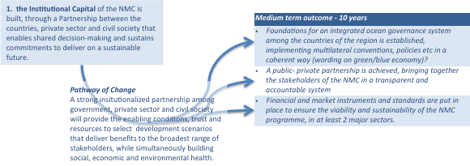

Example – Institutional Capital ->
(see next page for details)

Step. 5. Identifying medium term outcomes that will deliver the long term outcomes via the stated Pathway of Change.
Edit the boxes below to contribute. Use Track Changes if possible.
Long term outcome  25 years | Pathways of change | Medium term outcomes - 10 years
1. the Institutional Capital of the NMC is built, through a Partnership between the countries, private sector and civil society that enables shared decision-making and sustains commitments to deliver on a sustainable future. | A strong institutionalized partnership among government, private sector and civil society will provide the enabling conditions, trust and resources to select development scenarios that deliver benefits to the broadest range of stakeholders, while simultaneously building social, economic and environmental health. | Foundations for an integrated ocean governance system among the countries of the region are established, implementing multilateral conventions, and integrating national policies.
 |  | A broad-scale partnership is achieved, bringing together the stakeholders in the NMC in a transparent and accountable system.
 |  | Financial and market instruments, incentives and standards are put in place to ensure the viability and sustainability of the NMC programme, in at least 2 major sectors.
2. the Economic Capital of the NMC is grown, assuring food and livelihood security, and delivering wealth and prosperity equitably across the peoples of the region into the future. | When all major economic sectors, and key sectors that impact on the environment, are implemented on sustainability principles, prosperity and wealth will be grown for all peoples of the NMC. | In 2 key sectors, policy/legislation/regulation implement a Green/Blue economy approach favourable to development and valorizing natural and social assets of the NMC.
 |  | Coastal food and livelihood security is strengthened and economic opportunities diversified reaching 10% of the population of the NMC that is dependent on marine and coastal resources
 |  | In all major sectors, champions are identified and committed to bring about adoption of best practices and standards
3. the Natural Capital of the NMC is enhanced, such that critical ecosystems, species and ecological processes are protected, and support the people and economies of the region into the future. | When the foundational role of the environment in supplying goods and services to all economic sectors and to the people of the NMC is recognized and accounted for, natural capital will be appropriately valued and enhanced, thereby halting and even reversing loss of species and habitats. | The natural capital of the NMC is well understood and an ecosystem-based regime for management is in place across the NMC
 |  | Beyond Aichi Target 11 - improve the effectiveness of management in MPAs, LMMAs and other management areas to better deliver and sustain ecosystem services.
 |  | Adaptation to climate change and disasters, focusing on the most vulnerable people, places and sectors, is improved through strengthening and enhancing ecosystem-based resilience.
4. the Human and Knowledge Capital of the NMC is built, providing for the decision-making and technological progress that will assure the future of the region, and an informed and knowledgeable society. | Collectively, the people and governments of the NMC hold the future of the region in their hands, so investing in their education, knowledge and ability to make informed choices will be a prime driver of a prosperous and empowered society. | Build capacity within the NMC of professional cadres and a knowledge-based society, to support decision-making in the partnership.
 |  | Networking and knowledge exchange, valuing new and traditional knowledge systems, will build the human capital of the NMC.
 |  | Measurement and indicator systems and capacity is developed, providing the tools for assessment and decision-making, across all sectors of the NMC partnership.
 |  | Research and technological innovation are promoted, with primary institutions and networks in the NMC delivering world-class knowledge and technical solutions that support advances in major sectors.
5. the Social Capital of the NMC is enhanced and celebrated, ensuring the health, well-being and freedoms of the people of the region in a harmonious and just society. | The social fabric and value systems of the people of the NMC will determine the future of the region, so an integrated population-health-environment approach and an active and engaged civil society will be necessary to maximize benefits in and from the other Capitals | A more knowledgeable and empowered public better understands its world and participates actively in decision-making with other partners in the NMC.
 |  | The public health and welfare of 10% of the population of the NMC, focusing on the most vulnerable people and sectors of society, is improved.

Add further pages as necessary ->

Thinking about specific and project-focused objectives and needs
Edit the boxes below to contribute. Use Track Changes if possible.
Note that specific objectives and outcomes focused on individual sectors may be folded into the more general intermediate outcomes above. For example, “implementing a representative and ecologically connected network of MPAs” for a conservation group, and “establishing a sustainable fishery management regime for 5 target fisheries” for a fishery-oriented group, could both fall under “the natural capital of the NMC is well understood and an ecosystem-based regime for management is in place across the NMC”. The intermediate outcomes are intentionally general to enable inputs from very different sectors, all contributing to the same goal.
Details about you:

Date submitted: ____________________
Name of contact person: __________________
Email and address/contacts: ___________________
Additional contributors (how many?): ______________
Organization: ___________________

Please describe your background/perspective. If you have a profile/vision/ mission statements for your organization, please include those.

6. Developing indicators of success
The last component of a theory of change is to identify clear indicators of success for each of the main outcomes in the Pathways diagram. This will be done in later stages of the development of the NMC,

References. This presentation is simplified from these two primary resources:
Keystone (undated). Developing a Theory of Change. A Framework for Accountability and Learning for Social Change. A Keystone Guide http://www.keystoneaccountability.org/resources/guides
Vogel, I. 2012. ESPA guide to working with Theory of Change for research projects. ESPA/LTS/ITAD http://www.espa.ac.uk/files/espa/ESPA-Theory-of-Change-Manual-FINAL.pdf

